Dear Guest,

We wish you a warm welcome in Cimbarsaca.

Cimbarsaca, which is the Carolingian name for Semmerzake, is a charming B&B situated in a stylish mansion dating back to 1876. It was the home of a family of Semmerzake mayors.

As the daughter of a former mayor, I take particular pleasure in serving you all ingredients of an agreeable stay.

This guide aims at providing all necessary information on the B&B and its surroundings. Should you have more questions, do not hesitate to ask them.

I wish you a fine and relaxing stay and hope to be able to see you again in Cimbarsaca in the future.

Your hostess,

Luce

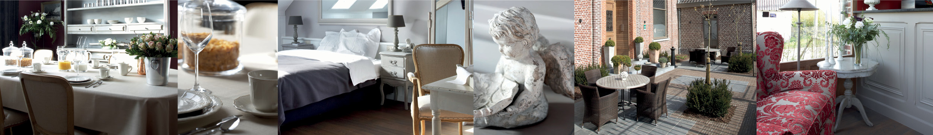

The ABCimbarsaca

A saying …
… that time has stood still here is perhaps slightly exaggerated but somehow the clock seems to tick just that little bit slower at Cimbarsaca.

Air-condition
In order to enable you to regulate room temperature, you will find the airco service panel next to the door.

Alarm service
Push the button “wekker” (wake up) of the telephone. Switch on the wake up, set up the time and save.

Arrival
You are welcome between 3 and 5 p.m. or later by appointment.

Assessment
Have you enjoyed your stay? Kindly assess on our website allowing others to share your Cimbarsaca experience.

Baby bed
No baby beds are available.

Baby care
You can change baby nappies in the toilet for the disabled on the ground floor.

Bar
Our attractive bar with two love seats and a view to the garden is situated on the ground floor and offers a wide range of drinks. It is open from 3 to 6 p.m. except on Sunday and festive holidays.

Bicycle friendly stay
B&B Cimbarsaca is biker friendly and has an eye for the needs of the biking tourists.

Bike hire
You can rent bikes and well-equipped tandems at the tourist info point De Poort, Markt 1, Gavere (T 09 389 29 80).
www.gavere.be

Biker’s outfit
Outfits can be dried in the cycle shed.

Breakfast

Breakfast is served from 7 a.m. until 10 a.m. in the breakfast room. On Sunday and festive holidays it is served from 9 a.m. until 11 a.m.

Check out
On the check-out day, we should like you to leave the room before or at 11 am sharp.

Cimbarsaca
Cimbarsaca is the Carolingian name for Semmerzake (814).

Coffee and tea corner
In the coffee and tea corner you can use a Nespresso machine with pads, a water kettle for tea and a microwave oven.

Conference room
Cimbarsaca has a conference room for up to 25 people (U-shape) or for 40 people (theatre arrangement). The place is ideal for conferencing in an oasis of peace and quiet.

Credit cards
The following credit cards will be accepted: MasterCard and Visa card.

Cycle repair set
There is a cycle repair set available for emergencies.

Cycle shed
Free use of a roofed and safely fenced cycle shed. Key can be obtained at check-in.

Daily paper
A daily newspaper can be provided by the hostess (11).

Do not disturb
The ‘do not disturb’ cards are in the welcoming file. Kindly attach the card on the outside of the room door when needed.

Electricity
Put your key badge into the slot.

Event
Cimbarsaca also has an event room that can host up to 40 people (seated) or 70 people (standing) for all kinds of company or family parties and receptions.

Feedback
Should you have any queries or suggestions, do not hesitate to tell the hostess. Of course, positive comment is welcome too.

Fire
In case of a fire emergency, contact the hostess as soon as possible. (11)
Go to the main exit by the staircase. There is a fireman in the house.

First aid kit
A first aid kit is available.

Garden and terrace
You will find the garden and terrace through the parking space following the walking path.

Gluten free
Gluten free, lactose free or other allergies? It is helpful if you let us know in advance when making the reservation.

Hospitality voucher
If you like to offer a special present to family, friends or (business) acquaintances, ask for our hospitality vouchers.

International emergency number
112

Internet
Access to internet is available in each room. You will find a plug-in cable in the table drawer in your room. Kindly put it back when done. Free Wi-Fi is available in the building.
Log-in code: cimbarsaca39

Jacuzzi
A wellness centre on the premises is currently ‘in the pipeline’.

Key badge
The key badge with the front door key will be on the room door upon arrival. The badge fits into the slot next to the door to ignite electricity.
Kindly hand in the badge to your hostess upon the check out!

Lost property
Lost property will be safely kept for one year. It will be returned upon request after post and package have been paid.

Maps
You will find a street map of Gavere in the welcoming file. It features the Valeir track for cycling (42 km). More walking and biking tours are at your disposal, ask your hostess.

Mini bar
Each room has its own mini bar. The welcoming aperitif, Roomer, and water are complimentary. Other or more drinks and snacks have to be paid. Kindly note down in the booklet in the folder the beverages you have taken out of the mini bar and show it upon checking out.

Packed lunch
At your request the hostess will prepare a (paying) packed lunch for you. Just let her know the day before.

Parking space
Parking is free on the premises. Kindly park the car in a parking lot

Payment
You can pay cash, by bancontact or credit card, i.e. only by Visa and MasterCard.

Peace at night
Allow yourself and the other residents the necessary peace and quiet at night, i.e. between 11 p.m. and 7 a.m.

Pets
Pets are not allowed.

Physician
If you need a physician, contact the hostess (11).

Restaurant
There are plenty of restaurants in the neighbourhood within a radius of 5 up to 10 km. You find them in the welcoming file.

Room cleaning
The rooms are cleaned every day between 11 a.m. and 3 p.m. If you like, you can hang the cleaning card at the outside of the room door.

Room service
Room service needs to be order before 12 a.m. The room service card is in the welcoming file.

Roomer
Roomer is the name of the delicious aperitif in a stylish round bottle made from elderflower according to traditional methods. It comes as a nice present. You can obtain more information on it from the hostess. (11)

Smoking
Smoking is not allowed inside the house. If smoking in a room is detected, the price for an extra night stay will be charged.

Taxi

BCService 0493 53 25 96 or 0494 24 72 24
You can book directly on www.bcservice.be, the company or congress code is Cimbarsaca in order to benefit from the prices mentioned (see file).
De Meyer 055 31 31 31

Telephone service
Your hostess Luce 11
Room to room 2 + room number
International emergency number 112
International or local calls: call 11 and the hostess will help you.

Television
The remote control is in the night table drawer.

‘Toerisme Vlaanderen’ (Flanders Tourism)
Is the proper authority giving the license to exploit B & Bs. If you need further information on exploitation rules and regulations for guest rooms you can address this authority. It will inform you on laws and give legal advice when there are conflicts about room exploitation. You can file a complaint to Toerisme Vlaanderen, Grasmarkt 60 - 1000 Brussels (T 02 504 03 65) www.toerismevlaanderen.be

Tourist information
You will find all sorts of tourist information in the coffee and tea corner. The Poorters of Gavere Tourist Info are ready to help you on to further information. Address: Markt 1 - 9890 Gavere (T 09 389 29 80) www.gavere.be

Uniquely situated
Cimbarsaca is the perfect base for all who would like to discover the Flemish Ardennes by bike or on foot. The historical cities of Ghent, Oudenaarde, Courtrai, Bruges and even Brussels are within easy reach. Flanders Expo Gent lies at a 20 minutes distance and Courtrai Xpo-halls are only some 30 minutes away.

Wi-Fi
Wireless internet is free and available all over the building. Log-in code is cimbarsaca39

X-number
Four stylish bedrooms with mezzanine are limited at hosting 3 persons per room.

Yes, I did it!
The old mayors’ mansion dating back to 1876 has been renovated over a period of four long years, which meant four hard winters.

Restaurants in the neighbouring area …

At 300 m …
Molenhof
Specials: grill on barbecue
Opperweg 29
9890 Gavere-Semmerzake
Tel 0475 66 46 86
www.grill-molenhof.be
Kitchen open on Thursday, Friday and Saturday from 7 p.m.
On Sunday from 12 till 2 p.m. and from 7 till 9 p.m.

At 1.6 km …
Den Gulzigen Bok
Retro style interior and garden
Gentweg 48
9890 Gavere-Vurste
Tel 09 384 75 72
www.dengulzigenbok.com
Kitchen all day long open on Thursday, Friday, Saturday and Sunday from 11 a.m.
In July and August the kitchen is also open from 5 p.m.

At 2.1 km …
Coffee house De Pourcq
Bakery – Coffee
Scheldestraat 34
9890 Gavere
Tel 09 384 08 61
Closed on Monday
Tuesday through Friday from 7 a.m. till 6.30 p.m.
Saturday from 7 a.m. till 6 p.m.
Sunday from 7 a.m. till 12.30 at noon

At 2.2 km …
De Post
Bar – Brasserie
Markt 2
9890 Gavere
Tel 09 384 54 28
www.cafebrasseriedepost.be
Closed on Monday and Tuesday
Kitchen open from 12 till 2 p.m. and from 6.30 till 10 p.m.
Snacks & tearoom 2 p.m. till 6.30 p.m.

At 2.4 km …
‘t Gavrije
Resto – bistro
Molenstraat 9
9890 Gavere
Tel 09 336 05 91
www.tgavrije.be
Closed on Wednesday and Thursday
Kitchen open from 11.30 a.m. till 9.30 p.m. and on Monday from 8.30 a.m. till 9.30 p.m.

At 2.6 km …
Mac Pudding
Restaurant – tea room
Sluis 7
9810 Eke-Nazareth
Tel 09 385 53 02
www.mac-pudding.be
Closed on Tuesday and Wednesday
Restaurant 12 till 2.30 p.m.
Tea room 2.30 till 6 p.m.
Restaurant 6.30 till 9.30 p.m.

At 3.2 km …
‘t Kwiezientje
Bistro
Stationsstraat 80
9890 Gavere-Asper
Tel 09 384 91 96
www.’tkwiezientje.be
Closed on Monday and Tuesday
Kitchen open on Wednesday, Thursday and Friday
From 11.30 a.m. till 2.30 p.m. and from 6 till 10 p.m.
On Saturday from 6 till 10 p.m.
On Sunday from 11 a.m. till 9 p.m.

At 3.4 km …
De Rotse
Bistro
Sint-Christianastraat 55
9890 Gavere-Dikkelvenne
Tel 0473 42 14 42
www.herbergderotse.be
Closed on Monday, Tuesday and Wednesday
Open from 11 a.m. till 10 p.m.
Kitchen open from 12 till 3 p.m. and from 6 till 9 p.m.

At 3.7 km …
Uilenspiegel
Spare ribs restaurant
Pontweg 120
9890 Gavere-Asper
Tel 09 384 24 54
Kitchen open on Friday (only in the evening), Saturday and Sunday (lunch time and evening)

At 4.3 km …
Haspra
Restaurant
Carlos Dierickxplein 2
9890 Gavere-Asper
Tel 0479 60 70 49
Closed on Monday and Friday

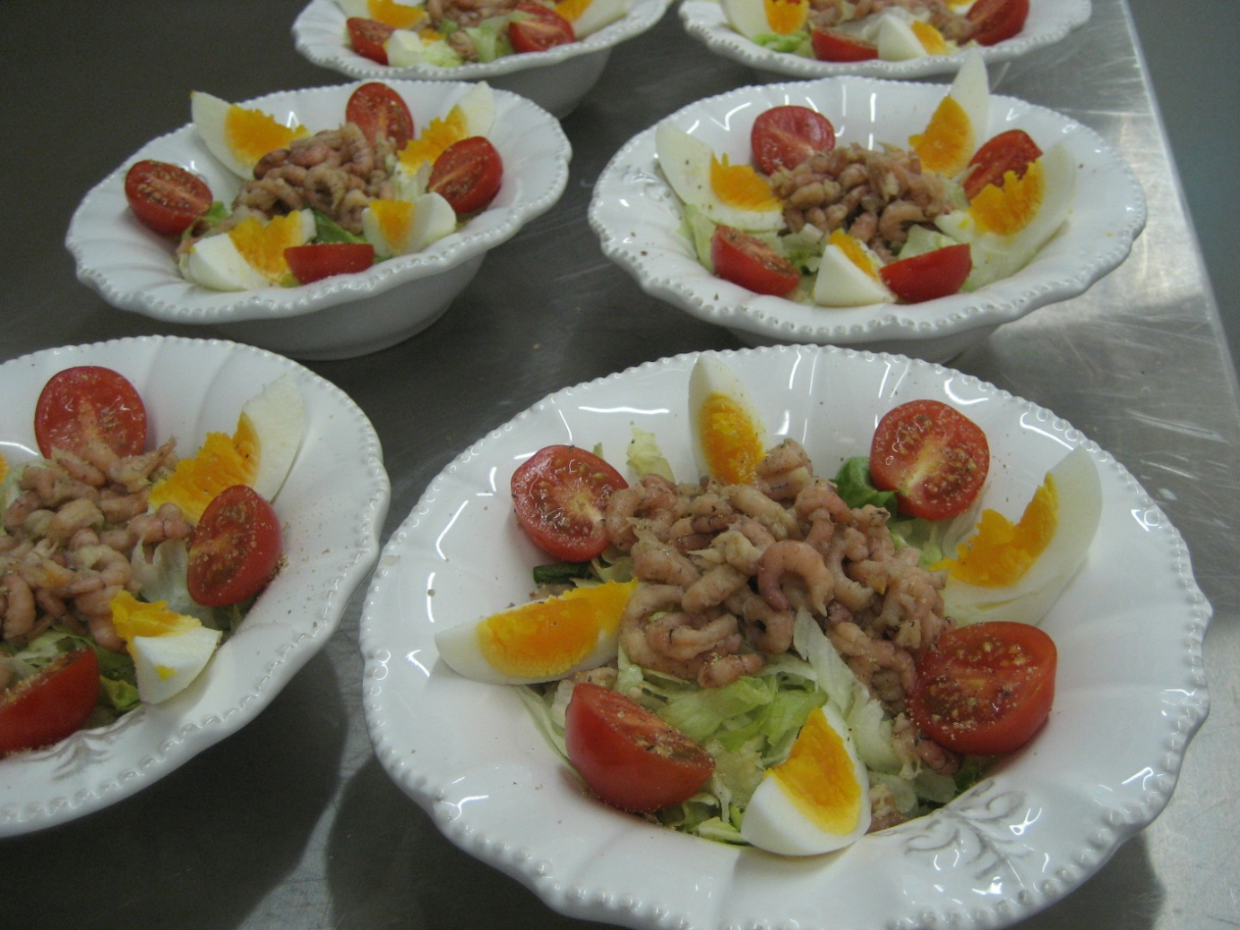

ROOM SERVICE

Room service

Room service on Monday, Tuesday and Wednesday from 6.30 p.m. till 10 p.m. on condition you have reserved before 12 at noon.

A bowl of soup and bread 5€00
Fruit salad 5€00
Salad Tomato/mozzarella 12€00
Salade Breydelhamkroket 12€50
Cheese croquette and lettuce 12€50
Spaghetti bolognese 12€50
Lasagne 14€00
Shrimp croquette and lettuce 16€50

Room service 7 on 7 if you have booked before 12 at noon

Cava M&M Brut (75 cl) 22€00
Prosecco La Jara brut (37,5 cl) 15€00
Prosecco La Jara brut (75 cl) 25€00
Prosecco La Jara rosé (37,5 cl) 20€00
Prosecco La Jara rosé (75 cl) 30€00
Champagne Jean Josselin brut (37,5 cl) 29€00
Champagne Jean Josselin brut (75 cl) 58€00

A plate of mixed nibbles and snacks 10€00

BC Service / BVBA Fulda

Leeuwerikstraat 28

B – 9840 De Pinte

BE 0830.297.729

0032/494.24.72.24 / 0032/493.53.25.96

info@bcservice.be / bookings@bcservice.be www.bcservice.eu

De Pinte, 13/12/2014
Dear Luce,

As requested these are the prices we offer:

From | to | Price 1 – 3 pax | Price 4 – 8 pax
B&B Cimbarsaca,  Dorpstraat 39,  B-9890 Semmerzake | Brussels Airport | € 105,00 | € 130,00
 | Brussels South Airport | € 135,00 | € 160,00
 | Lille Lesquin Airport | € 105,00 | € 130,00
 | Lille Europe of Flandre | € 105,00 | € 130,00
 | Brussels Midi Station | € 105,00 | € 130,00
 | Antwerpen | € 115,00 | € 145,00
 | Brugge | € 85,00 | € 110,00
 | Oostende | € 105,00 | € 130,00
 | Gent centrum (korenmarkt) | € 50,00 | € 70,00

- All prices include VAT (6%).
- Waiting times:
Airport or railway station: 30 minutes.
At company or hotel: 15 minutes.
After this €30,00 per hour will be charged calculated by the quarter.
- Parking tickets at the airport or station are included in the price.
- Péage or toll expenses will be charged separately.

We accept:

Reservations can be booked via our website, telephone or e-mail.

Should you have any further questions, do not hesitate to contact us!

With kind regards,

Patrick Buytaert Valerie Guyssens
(0494/24.72.24) (0493/53.25.96)
patrick@bcservice.be valerie@bcservice.be
Director Reservations & Booking

